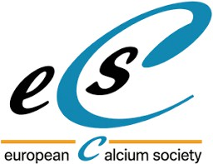 ECS 2026 Symposium on Calcium Remodeling as a Novel Aging Hallmark

The TMBIM family: ancestral calcium channels regulating cell death and stress responses
Name Institution

Abstract Tex….

